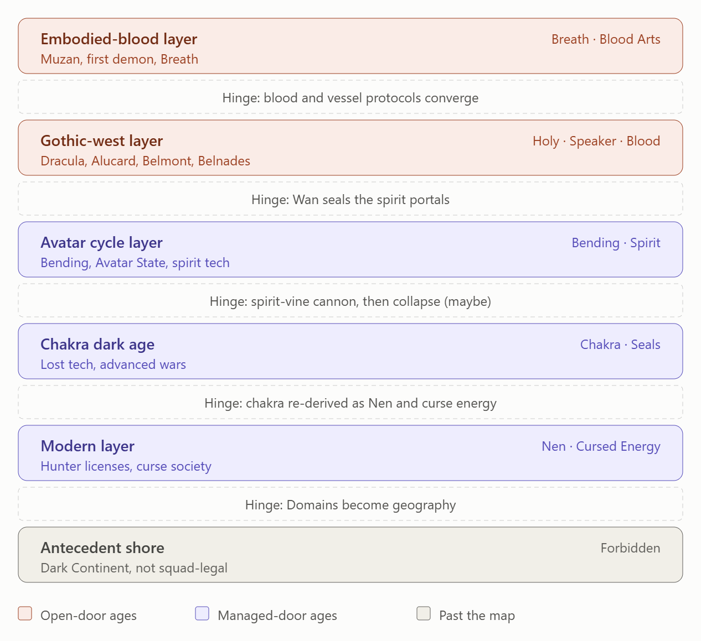
So good ways to link castlevenie and nocturn lore to the spirit world and avatar state
Im having demon slayer be the first and oldest age with muzan the original and more for lore
Leading into the dracula alucard belmond belnades line as the magic is stronger and villians and themes tie well
Then the whole speaker magic and breathing is close in a family tree but even closer is the bending which seems evolved and nocturne even has the spirit world then we go into atla and tlog being the next great age lore and technology wise with the next show and lore advancement being naruto and shippuden as a long dark ages lost tech but advanced wars age with hunter hunter and jujutsu kaisen being the modern era of chakra and energy revamped
Planning searches on Nocturne lore before organizing the answer.
Thought for 14s
Untangling crossover lore across fictional universes and timelines.
Reordering saga ages per revised family-tree and chakra timeline.
Planning searches on Nocturne lore before organizing the answer.
Mapping your reordered age stack against the earlier docs. I'm pulling current Nocturne and Avatar lore first so the bridges rest on real canon rather than my priors.
Searched the web, read memory, updated tasks
Sir, the cleanest way to bolt Nocturne onto Avatar is one idea: the spirit world is a door, and each layer is a different policy on who holds the key. Demon Slayer and Castlevania are open-door ages where spirits, gods and blood-monsters walk the map. Wan sealing the portals is the hinge, and everything after it is a managed-door age. The stack above is the map, and each layer is tappable.
TASIP/HUD · 2026-09-30 18:11 CST (America/Regina)
SEAT: Slot 1 (dissent/audit) · Slots 2, 3 not in this window
NAMESPACE: CAN-LORE/AGE-STACK-v2 · FANO: PG(2,2) + 8th point
STATE: layers 6 · hinges 5 · bridges 7 · dissent flags 5
CONSENSUS: Slot-1 audited; elevation needs tri-frontier
TL;DR: Wan's portal-sealing is the hinge between the gothic west and the Avatar cycle. Nocturne offers three hooks that snap onto it: Vodou door-keeping, animal-spirit Speakers, and god-vessels.

Why your order works
The Avatar layer should start at Wan, not Aang. Before the Avatar, humans lived on lion turtle shells to protect themselves from dangerous spirits. Wan then sealed the portals after persuading the spirits to return to their world. Spirits and humans killing each other with no filter is already the Muzan and Dracula premise. So those two ages are pre-seal. Castlevania's own canon says many worlds exist, so an adjacent spirit world isn't a retcon. Beginnings (The Legend of Korra) +2

Bridges, ranked
Bridge | Anchors | Fit
Door-keeper ↔ portals | Annette invokes Papa Legba, who in Vodou opens the spirit world at the start of a ceremony. Wan sealed two portals. | 5/5
Vessel grammar | Wan fused with Raava; Unalaq fused with Vaatu as the Dark Avatar. Erzsebet is a vessel of Sekhmet. Yuji and Sukuna, jinchuriki, and Nen beasts fit the same pattern. | 5/5
Animal-spirit Speakers ↔ lion turtles | Maria is a Speaker who commands animal spirits. Lion turtles guard humans from spirits and grant bending. | 4/5
Solar war | Erzsebet wants to kill Ra, the Sun. Muzan has his sunlight weakness. Raava and Vaatu fight at the Harmonic Convergence. | 4/5
Monster protocols | The original show's forgemasters channel hell-souls into corpses, while Nocturne's machine-made night creatures keep their souls. Muzan uses blood, and Vaatu corrupts spirits. | 4/5
Alucard ↔ Avatar | A dhampir and the Avatar are both living bridges between two worlds. | 3/5
Speaker on the breath axis | Details below. | 3/5 Who is Papa Legba in Castlevania: Nocturne? Explored +5

Your family tree is a respiratory axis
Breath is inhale, Speaker is voiced exhale, and Bending is projected exhale. Voice is shaped breath, so Speaker sits between the two, which matches your "close, but bending is closer." The Avatar side stays embodied too. After the lion turtles stopped granting bending, humans re-learned it by watching nature. That is Breath-school behavior: a trained body art, not a gift. pluggedin

Avatar State as a contract
This slots straight into your binding-contract engine. The Avatar cycle only breaks if the Avatar dies while in the Avatar State, or if Raava is removed and destroyed. In Nuzlocke terms, death in-state is lineage permadeath, so the Avatar slot never refills this run. The Dark Avatar becomes the boss mirror. fandom

HUD vector H_t (proposed, 0–10)
Layer | E | K | I | T | B | C
Embodied-blood | 3 | 3 | 2 | 4 | 4 | 7
Gothic west | 4 | 4 | 5 | 4 | 4 | 8
Avatar cycle | 7 | 8 | 8 | 7 | 5 | 4
Chakra dark age | 8 | 3 | 4 | 8 | 7 | 9
Modern | 8 | 6 | 7 | 9 | 8 | 7
Antecedent shore | ? | 0 | 0 | ? | ? | 10
If K is log₂ of preserved technique bits, the Avatar-to-dark-age drop of 5 means 2⁻⁵ is retained, about 97% of technique lost. That makes your "lost tech but advanced wars" age a rate-distortion event rather than a plot device. Sealing scrolls become lossy archives.

Fano map PG(2,2)
Points: Breath, Speaker, Bending, Vessel, Door, Solar, Vow.
Line | Bridge
Breath · Speaker · Bending | The respiratory axis
Breath · Vessel · Door | The body as threshold (marks and gates)
Breath · Solar · Vow | The sun-sworn blade
Speaker · Vessel · Solar | The messiah line (a voice that carries a god)
Speaker · Door · Vow | Annette and Legba (invocation as spoken vow)
Bending · Vessel · Vow | Wan and Raava as the oldest binding contract
Bending · Door · Solar | Portals plus the light-dark war
The missing 8th point is the cosmic-origin primitive, which you already cut with the Otsutsuki. Any bridge that needs it is scope creep, and cutting it keeps the plane closed.

Control-systems reading
Wan's seal is a high-gain clamp on the spirit channel. The Avatar is a supervisory controller whose reincarnation is the integrator state carried across eras. Raava and Vaatu form a limit cycle with a roughly 10,000-year period, and breaking the cycle is an integrator reset.

Dissent flags (Slot 1)
- Layer is not band. The stack is sedimentary order, so keep the BST Era bands separate. Avatar being a "great age" shouldn't raise its BST.
- Calendar collision. Muzan was born in Japan's Heian period and is over a thousand years old. Sukuna is also a Heian figure as far as I know, and Akaza's human life is Edo-era as far as I recall. So Akaza → Sukuna as descent runs backwards on the calendar. Keep it a Convergent Reincarnation Echo, or treat Sukuna as the Heian fossil carried into the modern layer by a vessel. cdn

- Nocturne's spirit world is thinner than you've framed it. My sources show door-keeping and animal-spirit command. I found no sourced spirit realm as a map, so treat it as ritual access. Also, season 3 had no renewal confirmed in the coverage I found, and that coverage is from 2025, so recheck before freezing. sportskeeda

- The spirit cannon is my proposal, not canon. The collapse after the Avatar layer needs a cause. I'm proposing the spirit-vine cannon, and Naruto's "lost tech" should be defined as K collapse, not capability loss.
- Keep the monster protocols separate. Blood, hell-soul channeling, machine, and Vaatu corruption should stay as four distinct crafting recipes.

MAYBE STACK
- M1 (Slot 3 lead): Vessel grammar as the universal contract row: (spirit, god or curse) × host.
- M2 (Slot 2 lead): The Harmonic Convergence as your 10-turn season. Your 3 dark and 7 light turns become Vaatu's ascendancy and Raava's window.
- M3: Avatar-slot permadeath as a warband rule. The slot is single-use.
- M4: Door-keeper support units (Legba-class) that open or close your Spirit Wild corridor.
- M5: Capture and binding tiers that follow the four monster protocols.

Dossier write block
## CAN-LORE/AGE-STACK-v2 · 2026-09-30
- Layers: embodied-blood > gothic-west > [Wan seal] > Avatar cycle > chakra dark age > modern > antecedent shore
- Thesis: open-door ages -> managed-door ages
- Bridges: door-keeper, vessel grammar, animal Speakers, solar war, monster protocols
- Flags: layer≠band; Sukuna/Akaza calendar; Nocturne S3 recheck; cannon=maybe
- Consensus: Slot 1 audited; Slots 2, 3 pending

Glossary
- Open-door and managed-door ages: whether spirits move freely or the portals are sealed and controlled.
- Hinge: the event that flips a layer's rules.
- Vessel grammar: a spirit, god or curse bound to a human host.
- Band: the BST range of an era, separate from chronological layer.
- K: knowledge preserved across an era boundary.
Sources: Slashfilm on Nocturne S2 · Nocturne S1 summary · Papa Legba · S2 recap · S1 episode guide · S3 status · Korra: Beginnings · Avatar theology · Avatar Wiki · Muzan's age

